**Chapter 4**

**RESULTS AND DISCUSSION**

This chapter presents the project description and structure, capabilities and limitations, project test results, and the evaluation results.

**Project Description**

The Android-based Queuing System Using QR Code was developed to improve the present queuing system used in most establishments. The main objective of this project was to design a system that allows companies to post configurable initial setup of transactions, generates QR code for customer’s queue, provides real-time transaction, and provides notification for customers.

The Android-based Queuing System Using QR Code was developed using web developing tools such as, PHP, HTML, Bootstrap 3, JavaScript, and MySQL and for the development of android application, Android Studio was used. The website runs on any Windows operating system and the android application runs on any Android phones with version 4.1 or higher.

The system was evaluated by 50 respondents, 40 from the students of Technological University of the Philippines – Manila, and 10 from IT professionals.

**Project Structure**

The project structure includes screenshot of the system with its respective description.

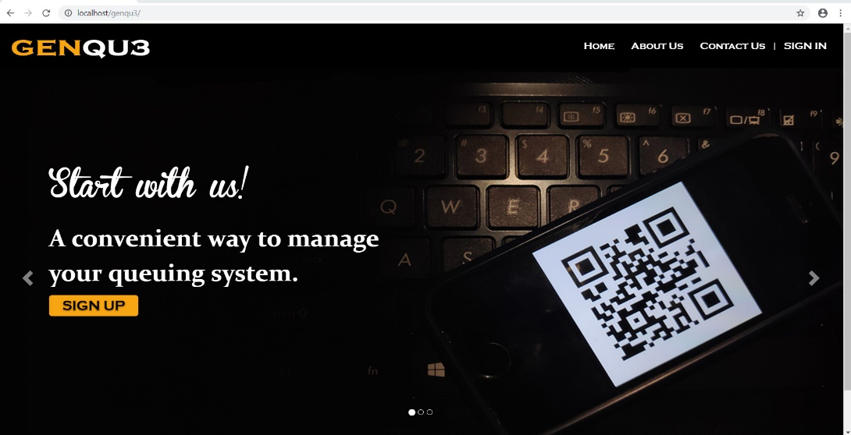

*Figure 11.* Home Page

Figure 11 shows the homepage of the website. Users can register by clicking the sign up button and they can login by clicking the sign in button. This is also where the users can see the about us and contact us page.

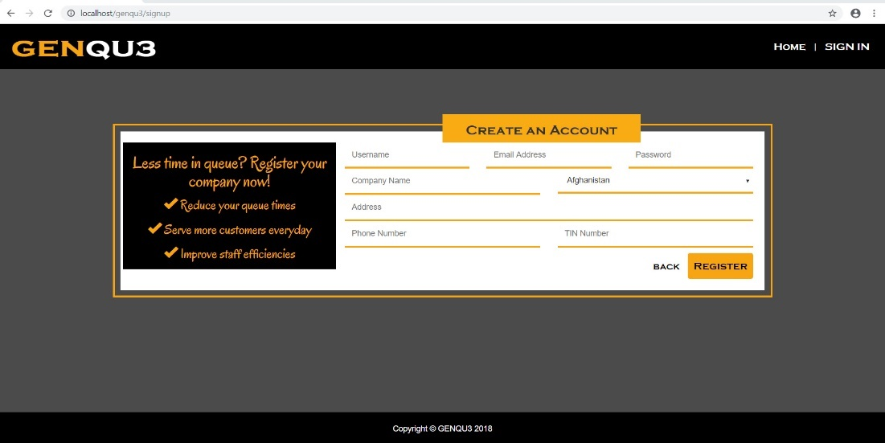

*Figure 12*. Signup Page

Figure 12 shows the signup page of the website. The form shows the required fields for the company to create an account.

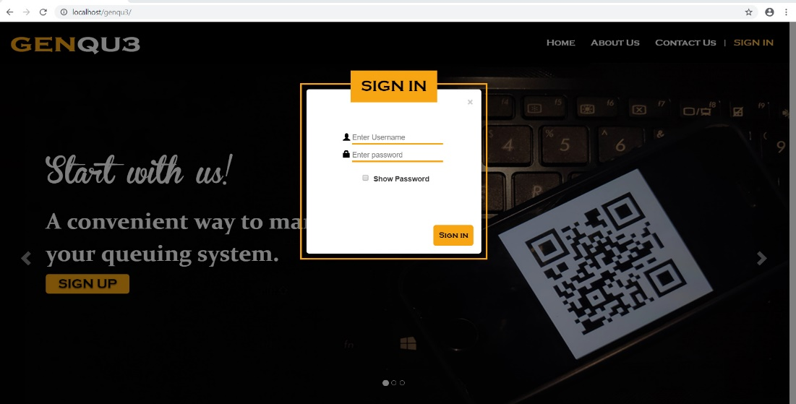

*Figure 13.* Login Page

Figure 13 shows the login page of the website. The form shows the required fields for the company, window and admin to login.

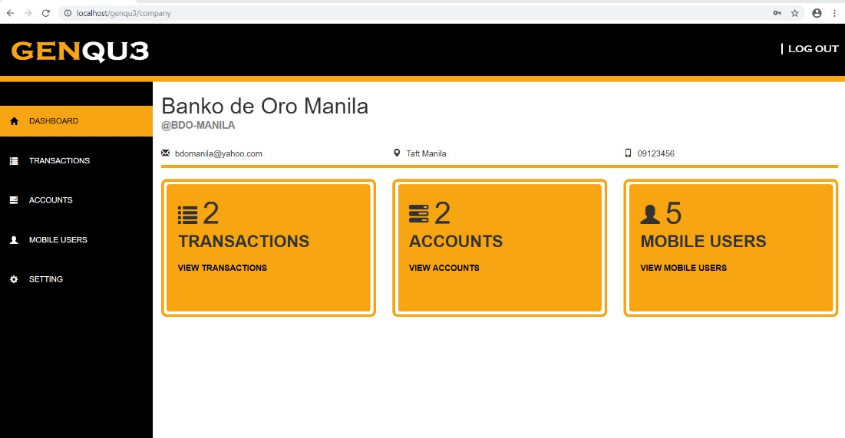

*Figure 14.* Company Dashboard

Figure 14 shows the company dashboard of the website. The company will see its basic information, the number of transactions, accounts and mobile users.

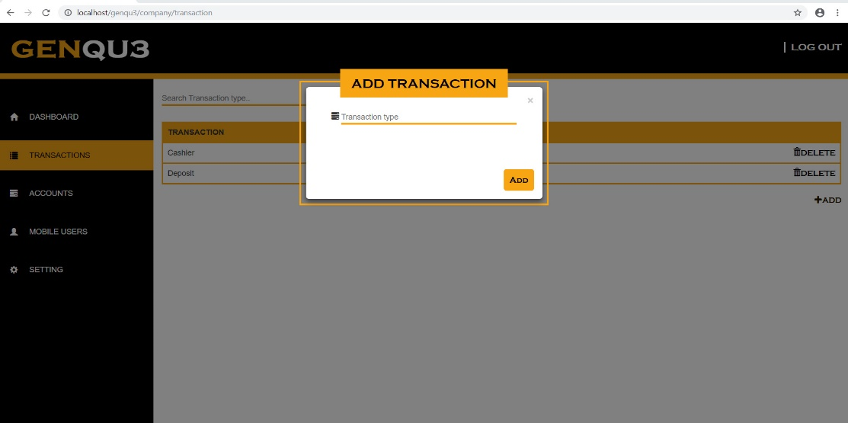

*Figure 15.* Add Transaction Type Page

Figure 15 shows the add transaction type page of the website. The form shows the required fields for the company to add a transaction type.

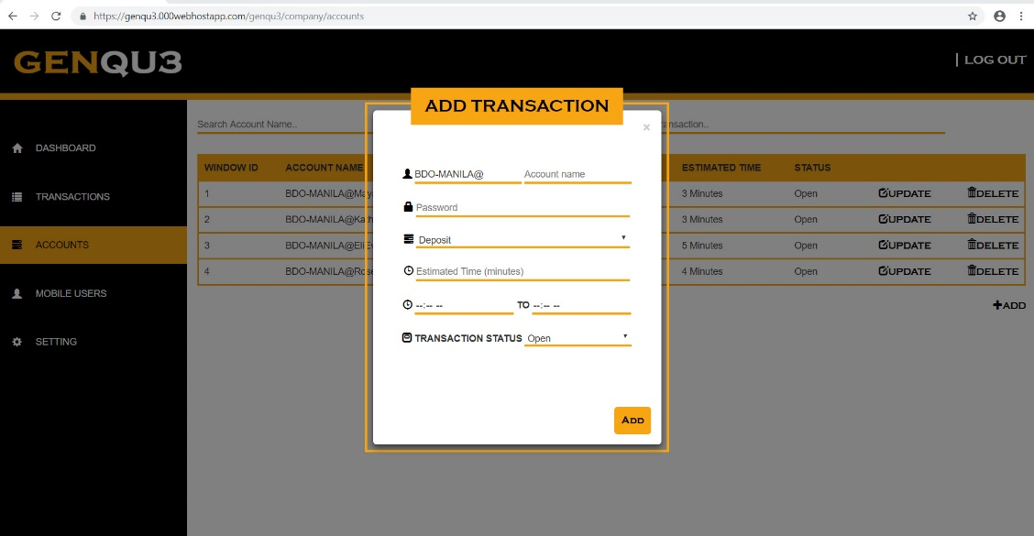

*Figure 16.* Add Transaction Account Page

Figure 16 shows the add transaction account page of the website. The form shows the required fields for the company to add a transaction account.

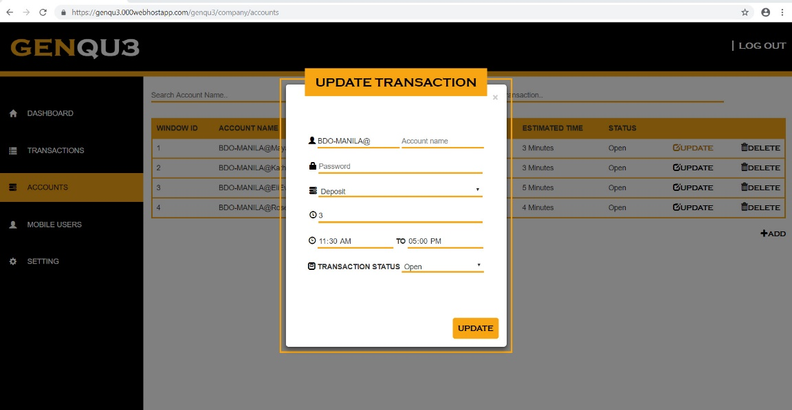

*Figure 17.* Update Transaction Account Page

Figure 17 shows the update transaction account page of the website. The form shows the required fields for the company to update a transaction account.

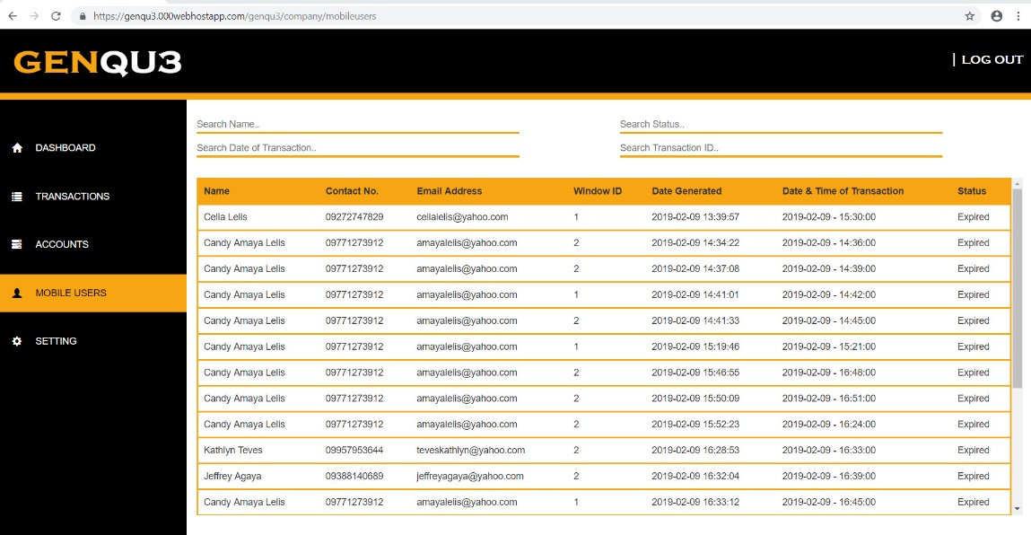

*Figure 18.* Mobile Users Page

Figure 18 shows the mobile users page of the website. The company will be able to see here the list of all the mobile users that made a transaction in their company.

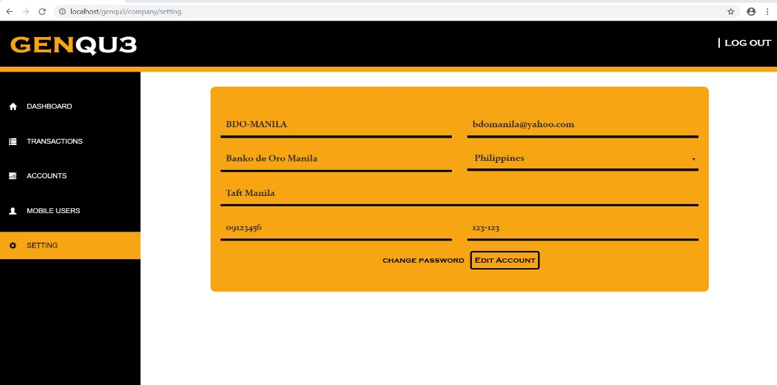

*Figure 19.* Settings Page

Figure 19 shows the settings page of the website. The company will be able to update here their information.

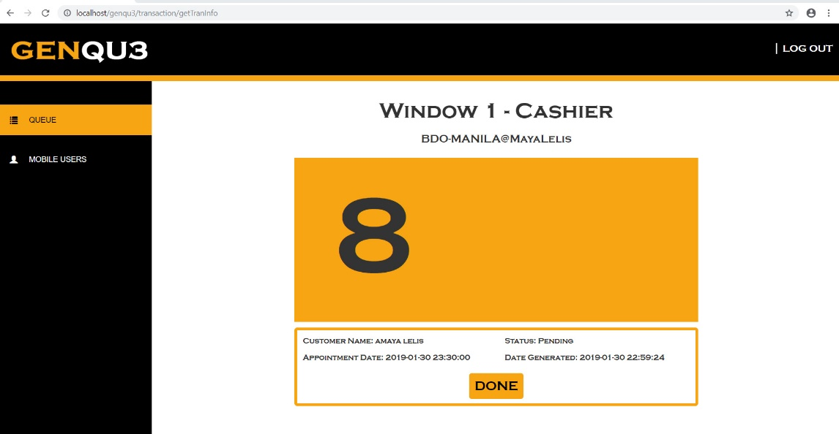

*Figure 20.* Queue Page

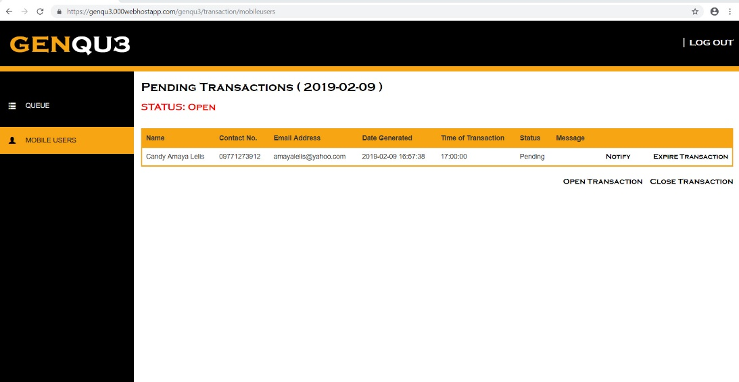 Figure 20 shows the queue page of the website. The person in charge in the window will be able to see the customer’s information after scanning their QR code and they will be able to mark the transaction expired if the customer’s transaction is done.

*Figure 21.* Mobile Users Page - Window

Figure 21 shows the mobile users page of the website for the window. The person in charge on that window will be able to see the list of all pending transactions on the current date and he/she will be able to notify the customer, expire the transaction of the customer and close all the transaction.

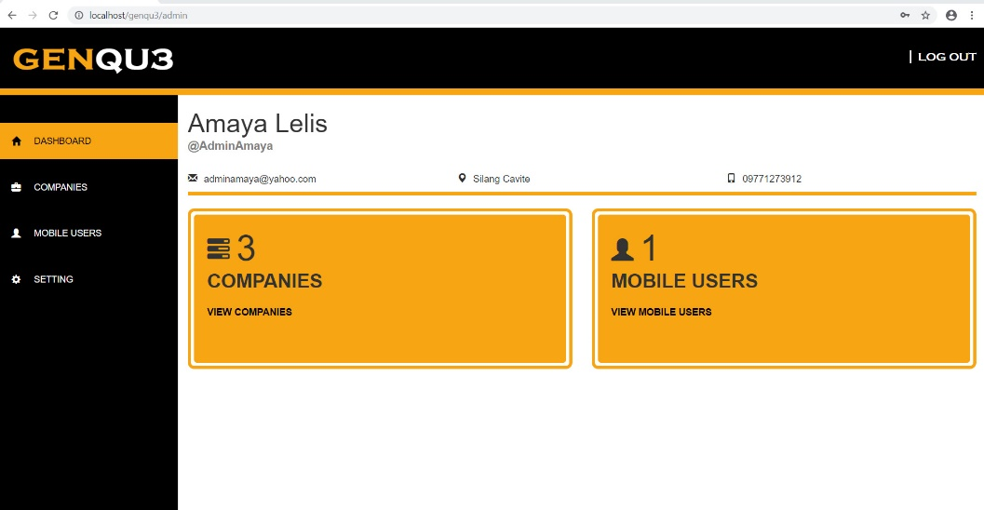

*Figure 22.* Admin Dashboard

Figure 22 shows the admin dashboard of the website. The admin will be able to see its basic information and as well as the number of companies and mobile users that are registered in the system.

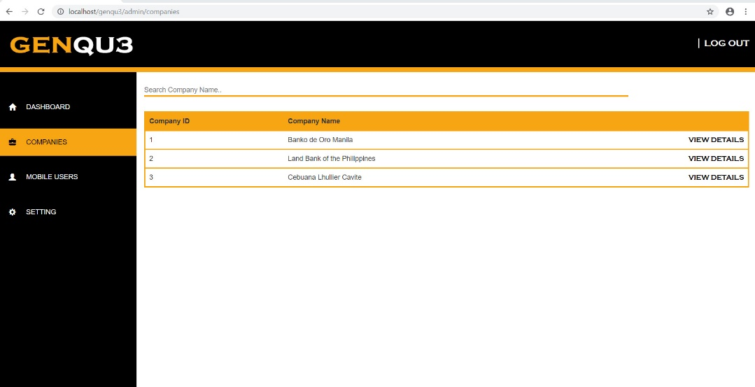

*Figure 23.* Companies Page

Figure 23 shows the companies page of the website. The admin will be able to see the list of all the companies that are registered in the system.

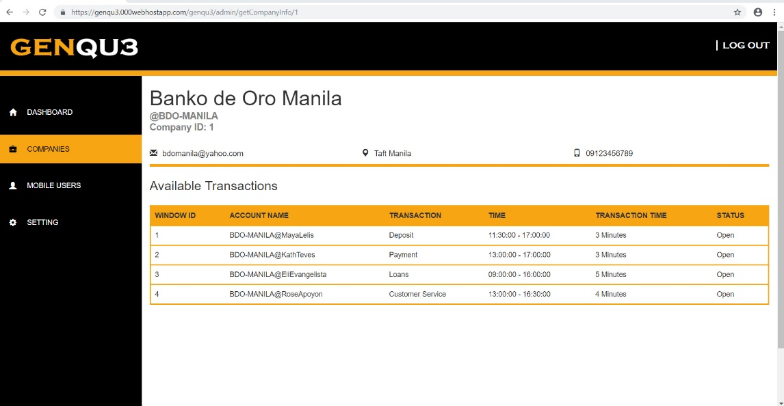

*Figure 24.* Company’s Details Page

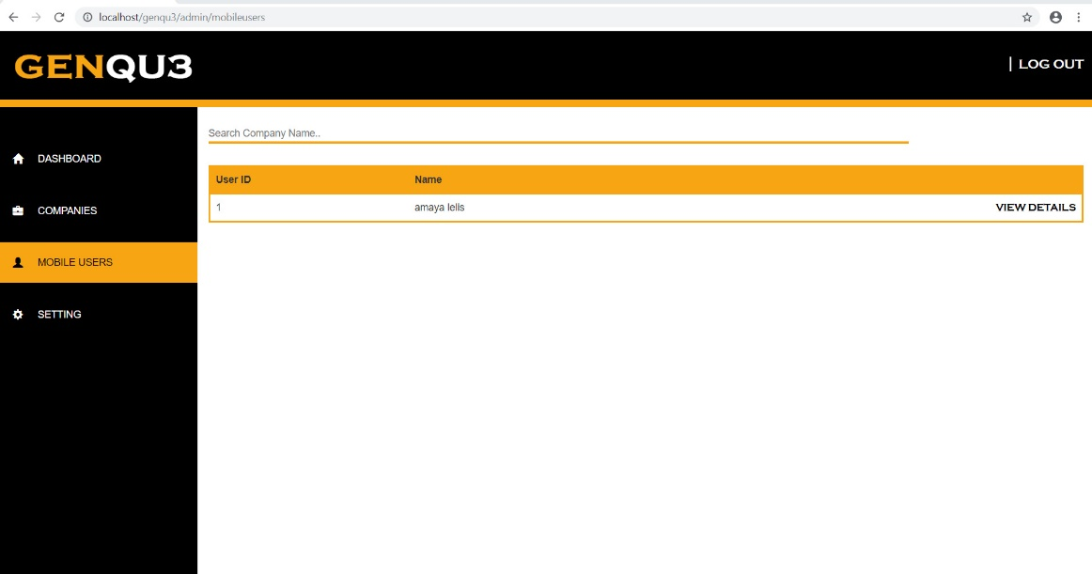 Figure 24 shows the company’s details page of the website. The admin will be able to see all the information of the company as well as the list and information of the company’s available transactions.

*Figure 25.* Mobile Users Page - Admin

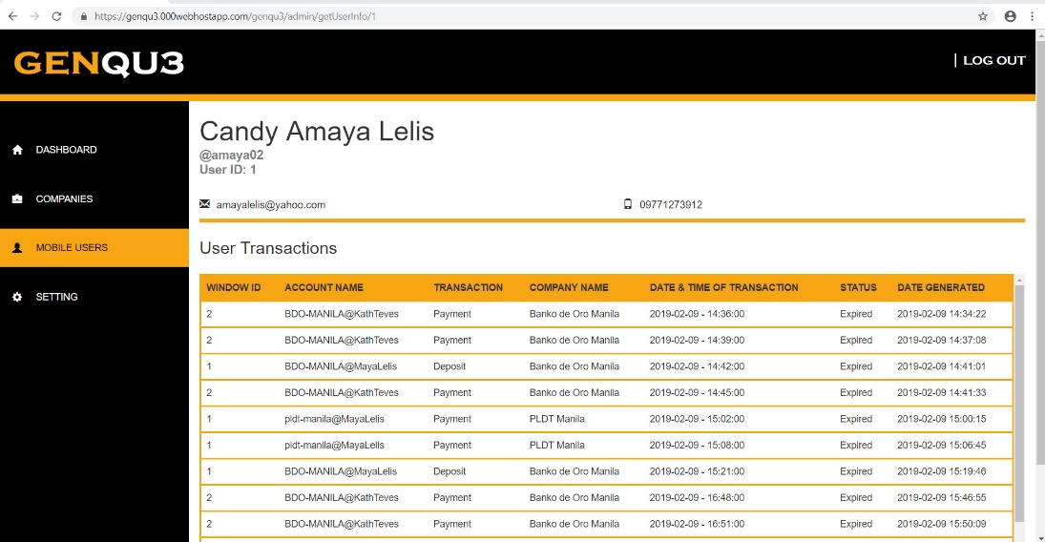 Figure 25 shows the mobile users page of the website for the admin. The admin will be able to see the list of all the mobile users that are registered in the system.

*Figure 26.* Mobile User’s Details Page

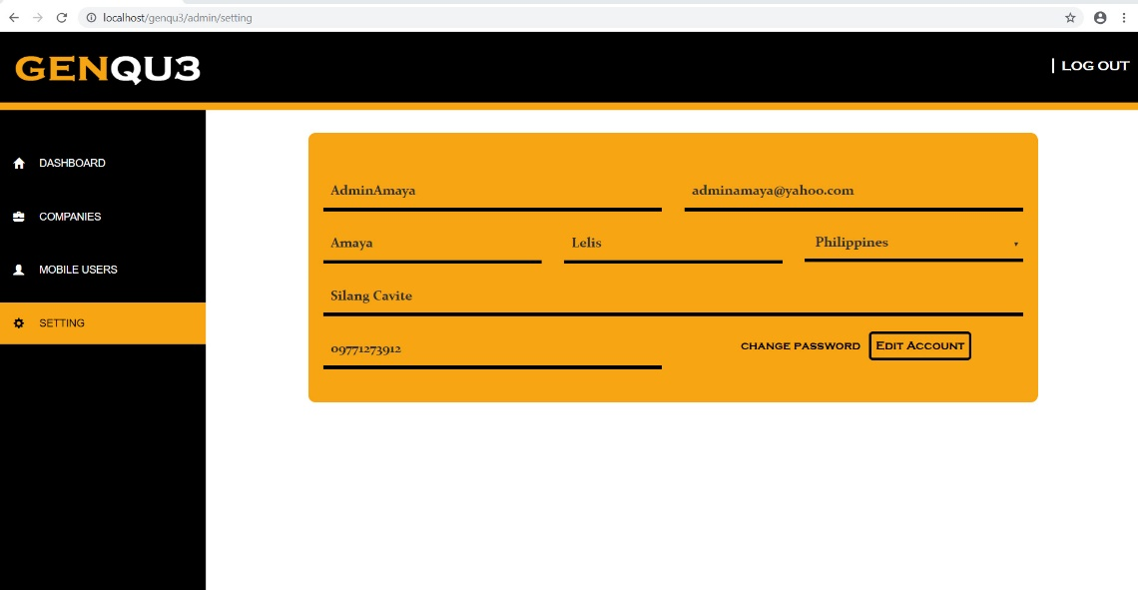 Figure 26 shows the mobile user’s details page of the website. The admin will be able to see all the information of the mobile user as well as the list and information of the transactions that the mobile user made.

*Figure 27.* Settings Page - Admin

Figure 27 shows the settings page of the website for the admin. The admin will be able to update here their information.

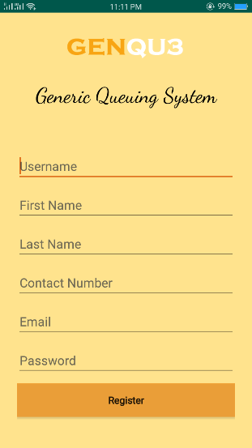

*Figure 28*. Signup Page – Android Application

Figure 28 shows the signup page of the android application. The form shows the required fields for the users to create an account.

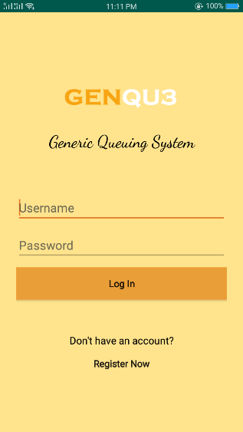

*Figure 29*. Login Page – Android Application

Figure 29 shows the login page of the android application. The form shows the required fields for the user to create an account.

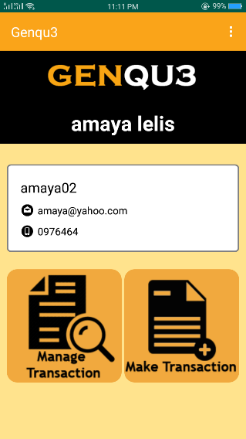

*Figure 30*. Profile Page – Android Application

Figure 30 shows the profile page of the android application. The user will be able to see its basic information and will have choice to make or manage transaction.

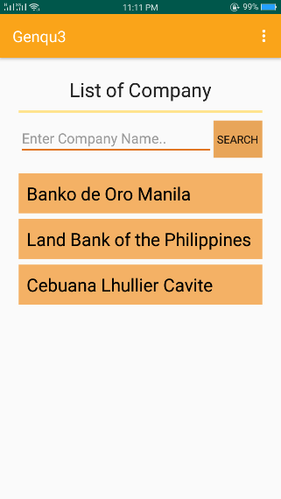

*Figure 31*. Company Page – Android Application

Figure 31 shows the company page of the android application. The users will see the list of all the companies that are registered in the system.

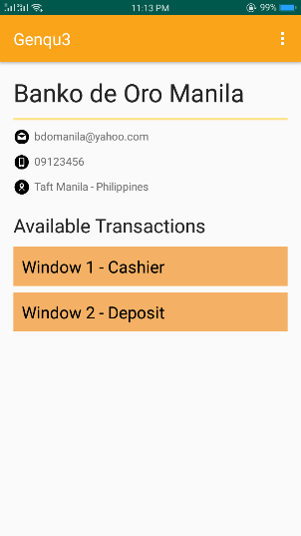

*Figure 32*. Transaction Page – Android Application

Figure 32 shows the transaction page of the android application. The user will be able to see the information and as well as the list of all available transactions on that company.

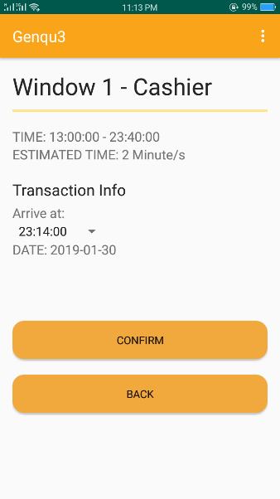

*Figure 33*. Confirm Transaction Page – Android Application

Figure 33 shows the confirm transaction page of the android application. The company will be able to see the information of that transaction and the user will be able to choose the time of his/her transaction.

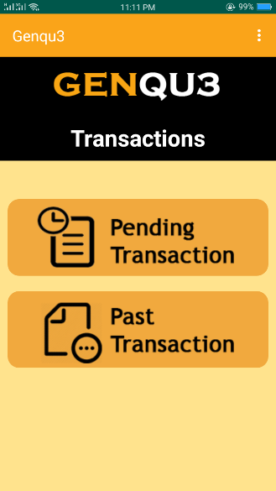

*Figure 34*. Manage Transactions Page – Android Application

Figure 34 shows the manage transaction page of the android application. The user will be able to choose what he/she wants to see between pending and past transactions.

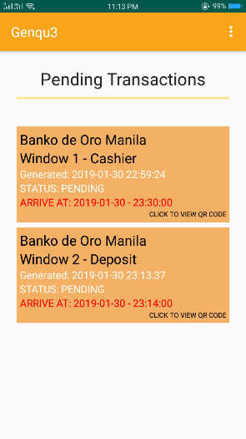

*Figure 35*. Pending Transactions Page – Android Application

Figure 15 shows the pending transactions page of the android application. The user will be able to see the list of all his/her pending transactions.

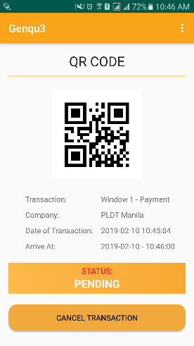

*Figure 36*. Pending QR Code– Android Application

Figure 36 shows the page for the pending QR code of the android application. The user will be able to see the generated QR code and cancel his/her pending transaction.

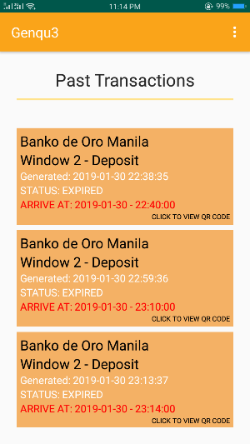

*Figure 37*. Past Transactions Page – Android Application

Figure 37 shows the past transactions page of the android application. The user will be able to see the list of all his/her past transactions.

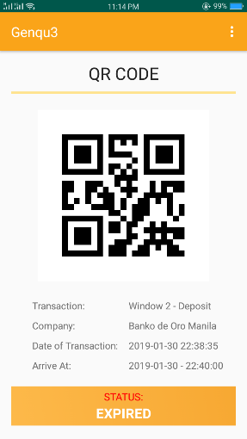

*Figure 38*. Past QR Code– Android Application

Figure 38 shows the page for the past QR code of the android application. The user will be able to see the generated QR code of his/her past transaction.

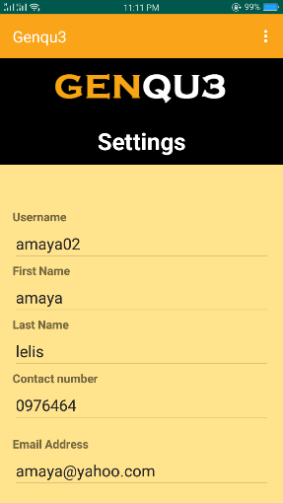

*Figure 39*. Settings Page – Android Application

Figure 39 shows the settings page of the android application. The user will be able to update his/her information here.

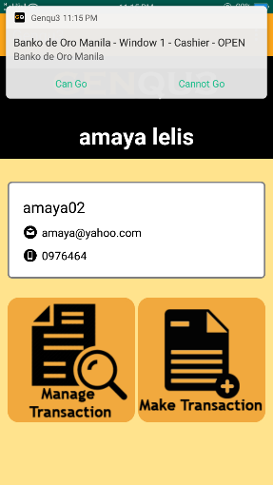

*Figure 40*. Notification – Android Application

Figure 40 shows the notification of the android application. The user will be notified by the person in charge in the window and the user will also be notified 1 hour before, 30 minutes before, 10 minutes before, 2 minutes before and if it is already his/her turn.

**Project Capabilities and Limitations**

The following are the capabilities of the project:

1. It allows companies to to post configurable initial setup of transactions.
2. The person assigned in a window or counter can notify a customer when the window is already available.
3. It can send notification to customers 1 hour before, 30 minutes before, 10 minutes before, 2 minutes before and when it is the customer’s turn.
4. It can use any network provider.
5. It has a user-friendly interface and it is easy to use.
6. It can generate QR code for the customer’s queue.

The following are the limitations of the project:

1. Those who only have an account can access the system.
2. The mobile application can only run on devices particularly smartphones that has an android version of 4.1 or higher.
3. Slow internet connection results to slow data gathering from the server.

**Text Result**

Table 5.

*Application Simulation Results*

|  |  |  |
| --- | --- | --- |
| **Type of User** | **Steps Undertaken** | **Results Taken** |
| Company | 1. Add transaction type 2. Add transaction account 3. Change settings | 1. The system was able to provide a platform for adding a transaction type. 2. The system was able to provide a platform for adding a transaction account. 3. The system was able to provide a platform for changing registered information. |
| Window | 1. Scan customer’s QR code 2. Notify customer 3. Expire transaction of a customer 4. Close all transaction | 1. The system was able to provide a platform that shows the customer’s information after scanning QR code. 2. The system was able to provide a platform for notifying customer. 3. The system was able to provide a platform for expiring transaction of a customer. 4. The system was able to provide a platform for closing all transaction. |
| Customer | 1. Make transaction 2. Choose company 3. Choose transaction 4. Choose schedule 5. View pending transactions 6. View QR code of pending transaction 7. View past transaction 8. View QR code of past transaction 9. Change settings | 1. The system was able to provide a platform that shows all the available companies. 2. The system was able to provide a platform that shows the information of the company and its available transactions. 3. The system was able to provide a platform that shows the information of the transaction as well as showing available schedules. 4. The system was able to provide a platform for adding a customer’s transaction. 5. The system was able to provide a platform for showing list of all pending transactions. 6. The system was able to provide a platform for generating QR code of pending transactions. 7. The system was able to provide a platform for showing list of all past transactions. 8. The system was able to provide a platform for generating QR code of past transactions. |

Table 5 obtained results noted from the table 2, expected result.

**Project Evaluation**

The system was evaluated by 50 respondents, where 40 are students in Technological University of the Philippines – Manila, and 10 are IT professionals. This is to determine its acceptability in terms of functionality, efficiency, compatibility, usability, reliability, security, maintainability, and portability.

Tables 6-14 present the results of evaluation for each criterion conducted to ensure that the said features and characteristic were achieved.

Table 6.

*Frequency of Functionality (n=50)*

|  |  |  |  |  |
| --- | --- | --- | --- | --- |
| **INDICATORS** | **4** | **3** | **2** | **1** |
| **Functionality** |  |  |  |  |
| 1. Completeness | 66% | 34% | 0 | 0 |
| 2. Correctness | 70% | 30% | 0 | 0 |
| 3. Appropriateness | 70% | 30% | 0 | 0 |
| **Overall Percentage** | **69%** | **31%** | **0** | **0** |

The overall result of the evaluation regarding the Functionality of the system is shown in table 6. 69% of the respondents rated the system with the score of 4 or “Highly Acceptable” and 31% rated with the score of 3 or “Very Acceptable” while 0% rated with a score of 2 or “Acceptable” and 1 or “Not Acceptable”.

Table 7.

*Frequency of Efficiency (n=50)*

|  |  |  |  |  |
| --- | --- | --- | --- | --- |
| **INDICATORS** | **4** | **3** | **2** | **1** |
| **Efficiency** |  |  |  |  |
| 1. Time behaviour | 62% | 38% | 0 | 0 |
| 2. Resource utilization | 74% | 26% | 0 | 0 |
| 3. Capacity | 62% | 38% | 0 | 0 |
| **Overall Percentage** | **66%** | **34%** | **0** | **0** |

The overall result of the evaluation in terms of the Efficiency of the system is shown in table 7. 66% of the respondents rated the system with the score of 4 or “Highly Acceptable” and 34% rated with the score of 3 or “Very Acceptable”. However, 0% rated with a score of 2 or “Acceptable” and 1 or “Not Acceptable”.

Table 8.

*Frequency of Compatibility (n=50)*

|  |  |  |  |  |
| --- | --- | --- | --- | --- |
| **INDICATORS** | **4** | **3** | **2** | **1** |
| **Compatibility** |  |  |  |  |
| 1. Co-existence | 58% | 42% | 0 | 0 |
| 2. Interoperability | 70% | 30% | 0 | 0 |
| **Overall Percentage** | **64%** | **36%** | **0** | **0** |

The overall result of the evaluation with regards to the Compatibility of the system is shown in table 8. 64% of the respondents rated the system with the score of 4 or “Highly Acceptable” and 36% rated with the score of 3 or “Very Acceptable” while 0% rated with a score of 2 or “Acceptable” and 1 or “Not Acceptable”.

Table 9.

*Frequency of Usability (n=50)*

|  |  |  |  |  |
| --- | --- | --- | --- | --- |
| **INDICATORS** | **4** | **3** | **2** | **1** |
| **Usability** |  |  |  |  |
| 1. Appropriateness | 68% | 32% | 0 | 0 |
| 2. Learnability | 62% | 38% | 0 | 0 |
| 3. Operability | 68% | 30% | 2% | 0 |
| 4. User Error Protection | 58% | 42% | 0 | 0 |
| 5. User Interface Aesthetics | 66% | 32% | 2% | 0 |
| 6. Accessibility | 60% | 40% | 0 | 0 |
| **Overall Percentage** | **63.67%** | **35.67%** | **0.67%** | **0** |

The overall result of the evaluation regarding the Usability of the system is shown in table 9. 63.67% of the respondents rated the system with the score of 4 or “Highly Acceptable”, 35.67% rated with the score of 3 or “Very Acceptable” and .67% rated with a score of 2 or “Acceptable” while there is no rating of 1 or “Not Acceptable” was given.

Table 10.

*Frequency of Reliability (n=50)*

|  |  |  |  |  |
| --- | --- | --- | --- | --- |
| **INDICATORS** | **4** | **3** | **2** | **1** |
| **Reliability** |  |  |  |  |
| 1. Maturity | 64% | 36% | 0 | 0 |
| 2. Availability | 70% | 30% | 0 | 0 |
| 3. Fault tolerance | 58% | 42% | 0 | 0 |
| 4. Recoverability | 78% | 22% | 0 | 0 |
| **Overall Percentage** | **67.50%** | **32.50%** | **0** | **0** |

The overall result of the evaluation in terms of the Reliability of the system is shown in table 10. 67.50% of the respondents rated the system with the score of 4 or “Highly Acceptable” and 32.50% rated with the score of 3 or “Very Acceptable” while 0% rated with a score of 2 or “Acceptable” and 1 or “Not Acceptable”.

Table 11.

*Frequency of Security (n=50)*

|  |  |  |  |  |
| --- | --- | --- | --- | --- |
| **INDICATORS** | **4** | **3** | **2** | **1** |
| **Security** |  |  |  |  |
| 1. Confidentiality | 58% | 42% | 0 | 0 |
| 2. Integrity | 72% | 28% | 0 | 0 |
| 3. Non-repudiation | 62% | 38% | 0 | 0 |
| 4. Accountability | 76% | 24% | 0 | 0 |
| 5. Authenticity | 78% | 22% | 0 | 0 |
| **Overall Percentage** | **69%** | **31%** | **0** | **0** |

The overall result of the evaluation with regards to the Security of the system is shown in table 11. 69% of the respondents rated the system with the score of 4 or “Highly Acceptable” and 31% rated with the score of 3 or “Very Acceptable” while 0% rated with a score of 2 or “Acceptable” and 1 or “Not Acceptable”.

Table 12.

*Frequency of Maintainability (n=50)*

|  |  |  |  |  |
| --- | --- | --- | --- | --- |
| **INDICATORS** | **4** | **3** | **2** | **1** |
| **Maintainability** |  |  |  |  |
| 1. Modularity | 70% | 30% | 0 | 0 |
| 2. Reusability | 72% | 28% | 0 | 0 |
| 3. Analyzability | 68% | 32% | 0 | 0 |
| 4. Modifiability | 80% | 20% | 0 | 0 |
| 5. Testability | 74% | 26% | 0 | 0 |
| **Overall Percentage** | **73%** | **27%** | **0** | **0** |

The overall result of the evaluation regarding the Maintainability of the system is shown in table 12. 73% of the respondents rated the system with the score of 4 or “Highly Acceptable” and 27% rated with the score of 3 or “Very Acceptable” while 0% rated with a score of 2 or “Acceptable” and 1 or “Not Acceptable”.

Table 13.

*Frequency of Portability (n=50)*

|  |  |  |  |  |
| --- | --- | --- | --- | --- |
| **INDICATORS** | **4** | **3** | **2** | **1** |
| **Portability** |  |  |  |  |
| 1. Adaptability | 68% | 30% | 2% | 0 |
| 2. Installability | 72% | 26% | 2% | 0 |
| 3. Replaceability | 60% | 38% | 2% | 0 |
| **Overall Percentage** | **67%** | **31%** | **2%** | **0** |

The overall result of the evaluation regarding the Portability of the system is shown in table 13. 67% of the respondents rated the system with the score of 4 or “Highly Acceptable” and 31% rated with the score of 3 or “Very Acceptable” while 2% rated with a score of 2 or “Acceptable” and 0% for 1 or “Not Acceptable”.

Table 14.

*Respondents’ Overall Frequency Rating of the System*

|  |  |  |  |  |
| --- | --- | --- | --- | --- |
| **CRITERIA** | **4** | **3** | **2** | **1** |
| 1. Functionality | 69% | 31% | 0 | 0 |
| 2. Efficiency | 66% | 34% | 0 | 0 |
| 3. Compatibility | 64% | 36% | 0 | 0 |
| 4. Usability | 63.67% | 35.67% | 0.67% | 0 |
| 5. Reliability | 67.50% | 32.50% | 0 | 0 |
| 6. Security | 69% | 31% | 0 | 0 |
| 7. Maintainability | 73% | 27% | 0 | 0 |
| 8. Portability | 67% | 31% | 2% | 0 |
| **Overall Percentage Frequency** | 67.40% | 32.27% | 0.33% | 0 |

Table 14 shows the overall frequency of the scores. 67.40% respondents rated the system for a score of 4 or “Highly Acceptable” for each criterion. 32.27% of respondents rated the system with a score of 3 or “Very Acceptable”, 0.33% of the respondents rated the system with a score of 2 or “acceptable” while none of the respondents rated the system with a score of 1.